**Chapter 3: Challenges and Remedies of Floods in Maharashtra**

**3.1 Challenges in Flood Management**

Flood management in Maharashtra faces numerous challenges that hinder effective prevention and mitigation. These challenges can be categorized into infrastructural, administrative, financial, and community-based issues.

**3.1.1 Infrastructural Challenges**

**Inadequate Drainage Systems:**

Many urban areas in Maharashtra, particularly Mumbai, have outdated and insufficient drainage systems. These systems are not equipped to handle the heavy rainfall that the region often experiences during the monsoon season. The lack of proper drainage leads to severe waterlogging and flooding, disrupting daily life and causing significant damage.

**Encroachment on Water Bodies:**

Unauthorized construction on riverbanks, floodplains, and wetlands reduces the natural capacity of these areas to absorb floodwaters. Urbanization has led to the conversion of many natural water bodies into residential and commercial areas, exacerbating the risk of flooding.

**Aging Infrastructure:**

Dams, levees, and embankments in some regions of Maharashtra are old and require urgent maintenance or upgrading. Many of these structures were built decades ago and are not designed to handle the increased volume and intensity of rainfall seen today.

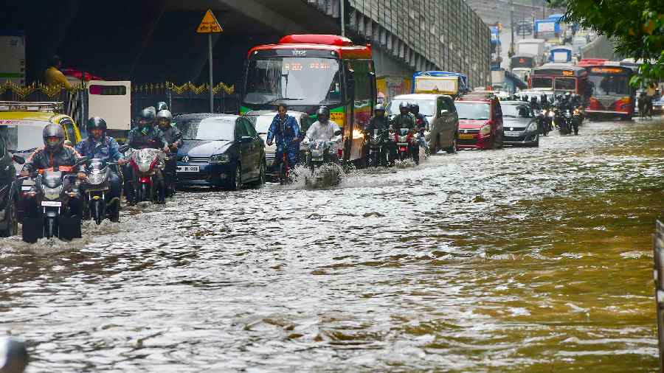

**Image 3.1: Waterlogged streets in Mumbai during a flood**

**3.1.2 Administrative Challenges**

**Coordination Between Agencies:**

Effective flood management requires seamless coordination between various governmental departments and agencies. However, there is often a lack of communication and collaboration, leading to fragmented and inefficient responses to flood situations.

**Policy Implementation:**

Despite having policies and plans in place for flood management, the implementation at the ground level is frequently inefficient and inconsistent. Local authorities may lack the resources or capacity to enforce these policies effectively.

**Data and Information Sharing:**

Inadequate sharing of data and information between agencies hampers effective flood forecasting and early warning dissemination. Real-time data on weather patterns, river levels, and other critical factors are essential for timely and accurate flood warnings.

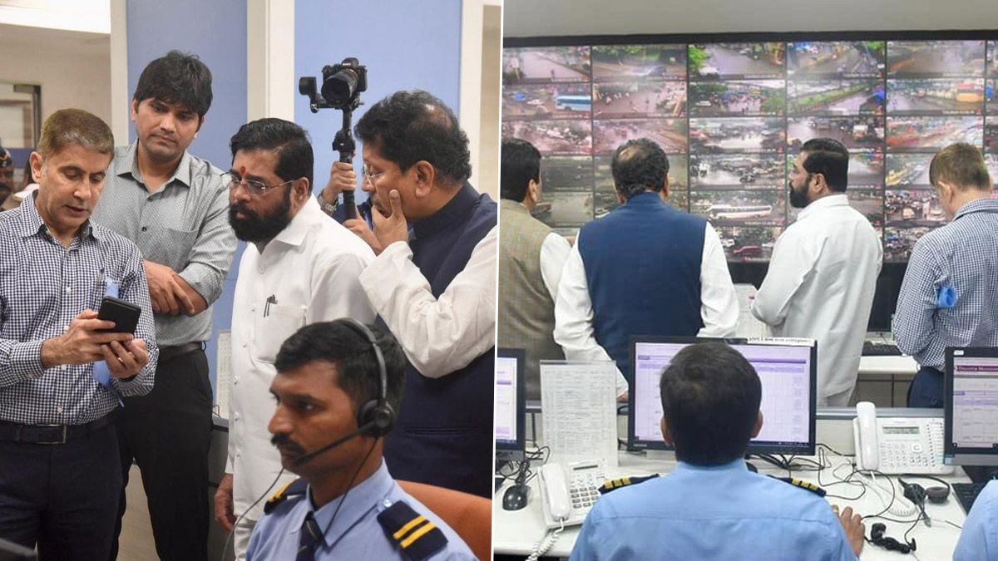

**Image 3.2: Government officials in a meeting discussing flood response strategies**

**3.1.3 Financial Challenges**

**Funding Constraints:**

Insufficient budget allocation for flood management and mitigation projects delays critical infrastrcture development. Many flood-prone areas lack the necessary funds to implement effective flood prevention measures.

**Disaster Relief Funds:**

Delays in the disbursement and allocation of disaster relief funds affect the timely recovery and rehabilitation of affected communities. Bureaucratic hurdles and inefficiencies often slow down the process of getting aid to those in need.

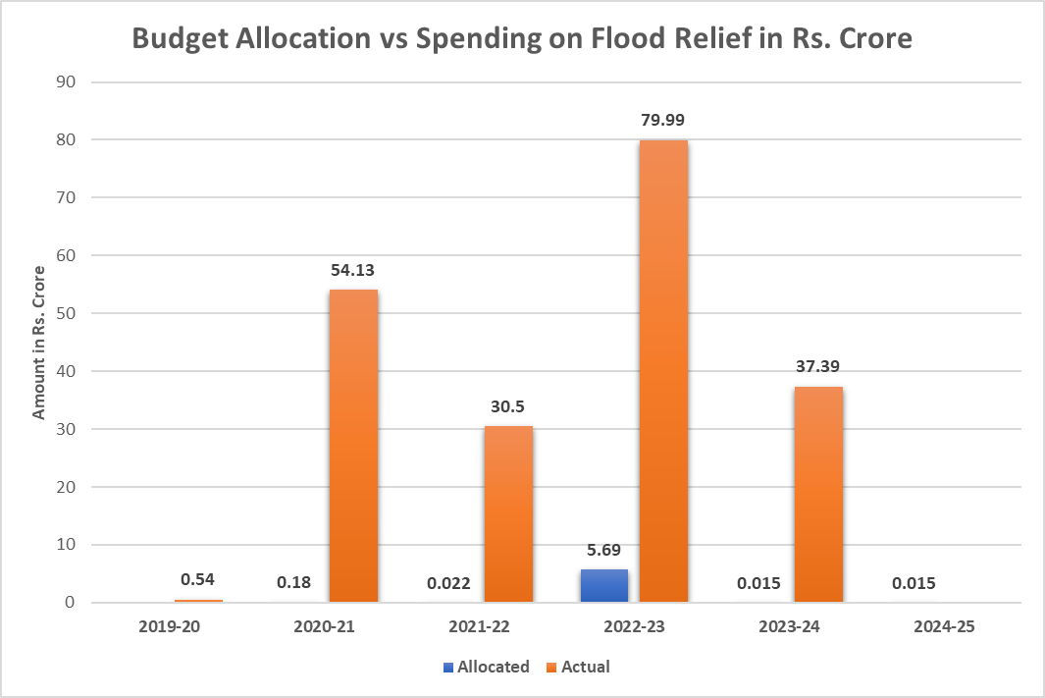

**Image 3.3: Graph showing budget allocation trends for flood management**

3.1.4 Community-Based Challenges

**Public Awareness and Preparedness:**

Lack of awareness and preparedness among communities about flood risks and response measures exacerbates the impact of floods. Many residents of flood-prone areas are unaware of the steps they can take to protect themselves and their property.

**Migration and Informal Settlements:**

High rates of migration to urban areas lead to the growth of informal settlements in vulnerable zones, increasing the risk of flood damage. These settlements often lack proper infrastructure and are built in areas prone to flooding.

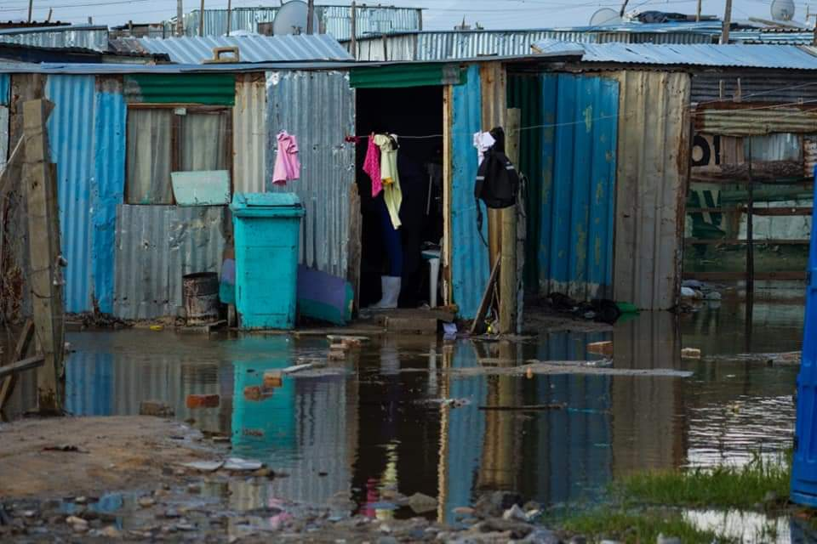

**Image 3.4: Informal settlements in a flood-prone area**

**3.2 Impact of Floods**

Floods have a wide-ranging impact on various aspects of society, economy, and the environment. Understanding these impacts is crucial for developing effective mitigation and response strategies.

**3.2.1 Social Impact**

**Loss of Life and Injury:**

Floods can result in significant loss of life and cause injuries to many people. The immediate effects of drowning, physical trauma, and exposure to hazardous conditions during floods contribute to high mortality and morbidity rates.

**Displacement and Homelessness:**

Floods often force people to leave their homes, leading to temporary or permanent displacement. Evacuated individuals face challenges in finding shelter, food, and basic necessities, and prolonged displacement can have severe psychological and social consequences.

**Health Issues:**

Standing floodwaters can become breeding grounds for waterborne diseases such as cholera, dengue, and malaria. Lack of access to clean drinking water and sanitation facilities further exacerbates health risks for affected populations.

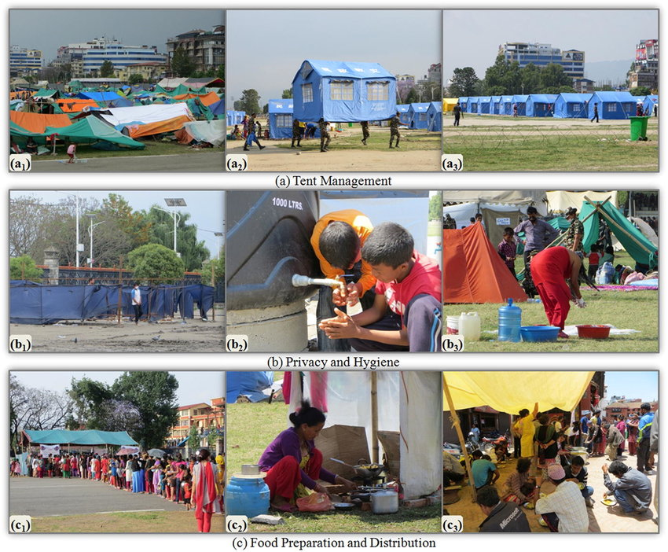

**Image 3.5: Displaced families in temporary shelters after a flood**

**3.2.2 Economic Impact**

**Damage to Property and Infrastructure:**

Floods cause extensive damage to homes, commercial buildings, roads, bridges, and other infrastructure. The repair and rebuilding costs are significant, and the economic burden falls heavily on individuals, businesses, and governments.

**Loss of Livelihood:**

Agricultural lands and crops are often destroyed by floods, leading to a loss of income for farmers. Small businesses and industries also suffer from flood damage, resulting in job losses and economic instability.

**Insurance Claims and Financial Strain:**

The surge in insurance claims following floods puts financial strain on insurance companies and can lead to increased premiums. For those without insurance, the financial impact of rebuilding and recovery can be devastating.

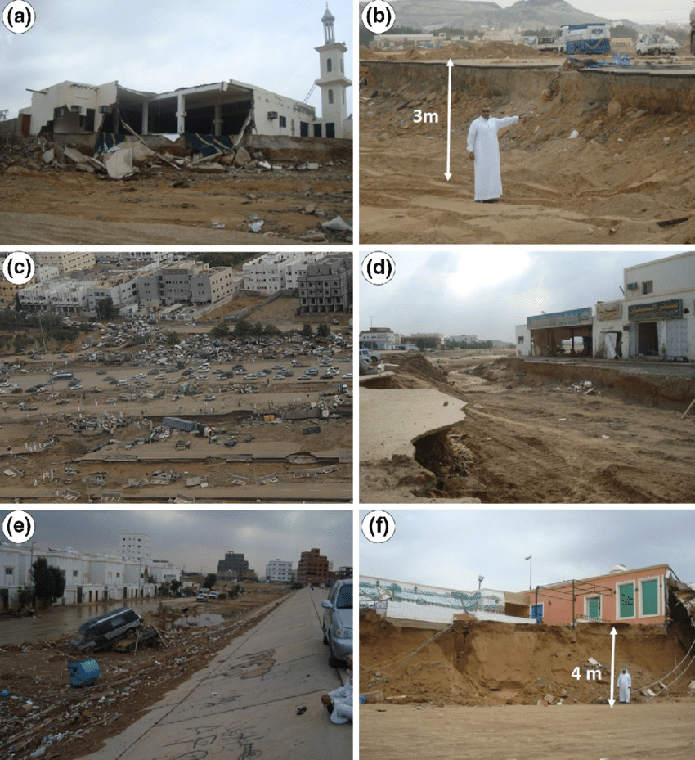

**Image 3.6: Flood-damaged infrastructure and property**

**3.2.3 Environmental Impact**

**Erosion and Sedimentation:**

Floods cause soil erosion and the deposition of sediment in riverbeds and floodplains. This can alter the landscape, affect agricultural productivity, and disrupt natural habitats.

**Water Quality Degradation:**

Floodwaters often carry pollutants, chemicals, and debris, leading to contamination of water sources. This can affect drinking water supplies, harm aquatic ecosystems, and pose long-term environmental challenges.

**Loss of Biodiversity:**

Floods can lead to the loss of flora and fauna in affected areas. The destruction of natural habitats and the displacement of wildlife disrupts ecosystems and can lead to a decline in biodiversity.

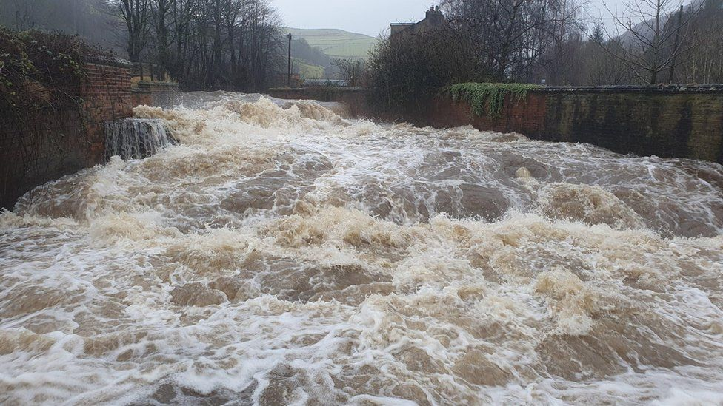

**Image 3.7: Environmental impact of floods on a river ecosystem**

**3.3 Flood Economy and Responses**

The economic impact of floods extends beyond immediate damage, influencing long-term economic stability and growth. Effective responses to floods are crucial for mitigating these impacts and ensuring swift recovery.

**3.3.1 Economic Responses**

**Government Relief Programs:**

Governments often implement relief programs to support affected communities. These programs may include financial aid, subsidies for rebuilding, and provision of essential services.

**International Aid and Assistance:**

In severe flood events, international organizations and countries may provide aid and assistance. This can include financial support, humanitarian aid, and technical expertise in disaster management.

**Insurance and Risk Management:**

Developing comprehensive insurance schemes and risk management strategies can help mitigate the financial impact of floods. Encouraging individuals and businesses to adopt flood insurance can provide a safety net and support faster recovery.

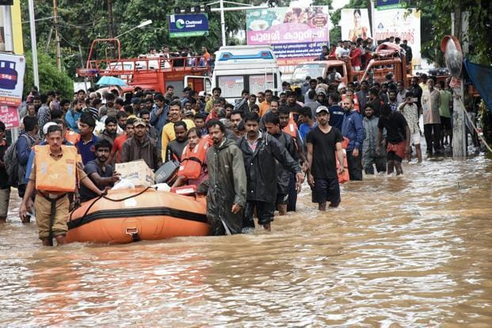

**Image 3.8: Government relief efforts following a flood**

**3.3.2 Infrastructure and Technological Responses**

**Early Warning Systems:**

Implementing advanced early warning systems can provide timely alerts to communities, allowing them to evacuate and take necessary precautions. These systems use real-time data from weather stations, river gauges, and satellite imagery.

**Flood-Resilient Infrastructure:**

Investing in flood-resilient infrastructure, such as elevated buildings, flood barriers, and drainage systems, can reduce the impact of floods. Urban planning and zoning regulations should incorporate flood risk assessments to ensure sustainable development.

**Technology and Innovation:**

Leveraging technology and innovation, such as remote sensing, GIS mapping, and predictive modeling, can enhance flood management. These tools can improve flood forecasting, risk assessment, and emergency response planning.

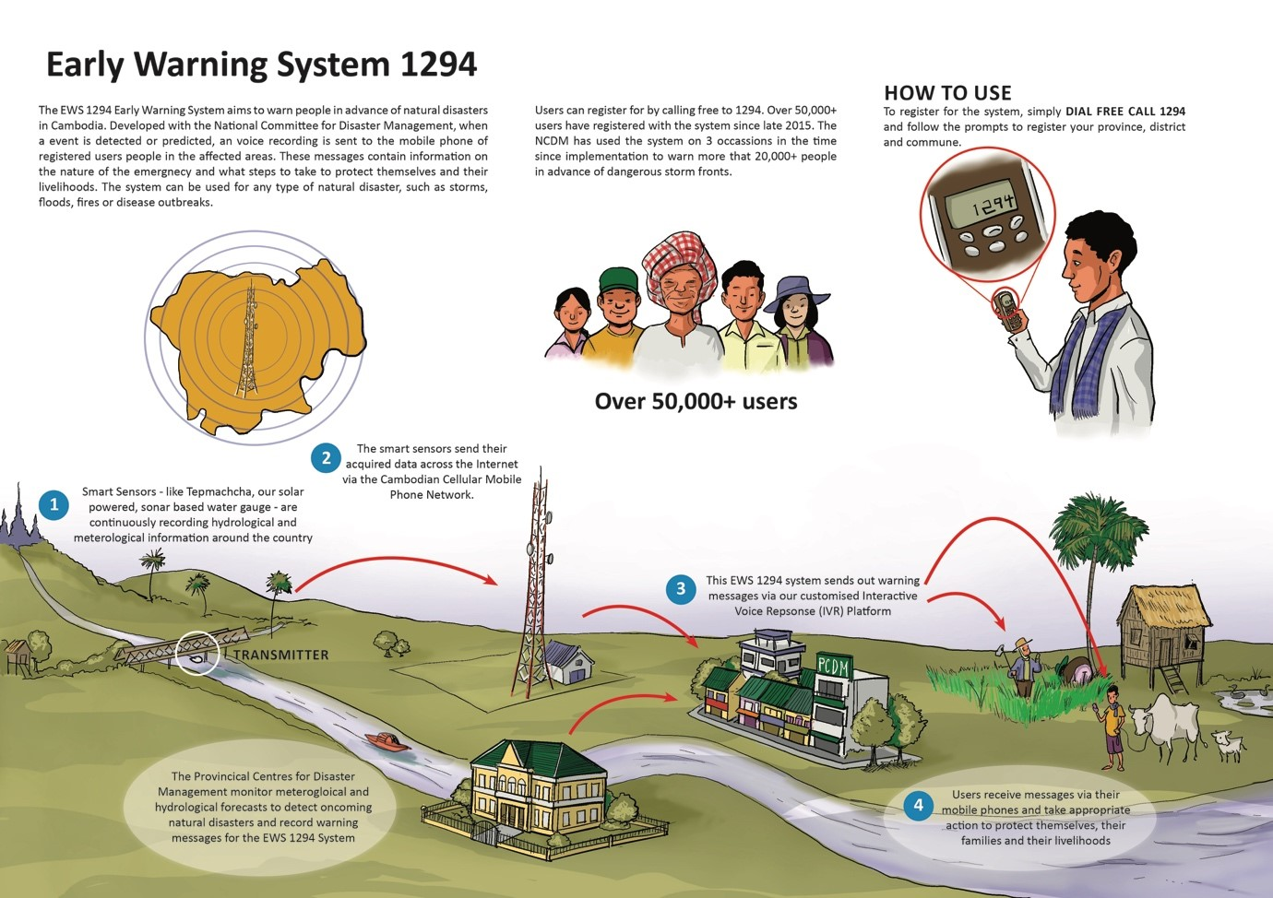

**Image 3.9: Early warning system for flood**

3.4 Flood Response Forces

In the event of a flood, various specialized forces and agencies play a crucial role in rescue and relief operations. These forces include disaster response teams, military units, and volunteer organizations.

**3.4.1 Task Forces and Disaster Response Teams**

**National Disaster Response Force (NDRF):**

The NDRF is a specialized force in India tasked with disaster response and relief operations. They are equipped with trained personnel and advanced equipment to conduct rescue missions, provide medical aid, and support recovery efforts.

**State Disaster Response Forces (SDRF):**

Each state in India has its own SDRF to respond to local disasters. These forces work in coordination with the NDRF and other agencies to ensure timely and effective response to flood situations.

**Local Emergency Services**:

Local emergency services, including fire brigades, police, and medical teams, are often the first responders during floods. Their quick action and coordination are vital for saving lives and minimizing damage.

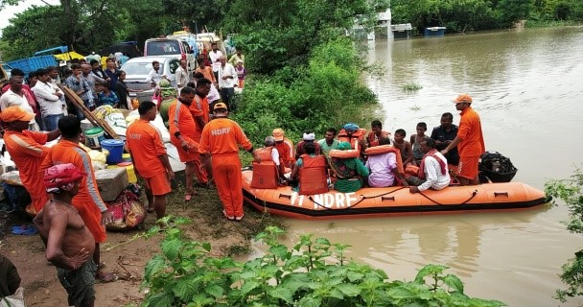

**Image 3.10: NDRF team conducting a rescue operation during a flood**

**3.4.2 Military and Paramilitary Forces**

**Indian Army:**

The Indian Army plays a significant role in flood relief operations. They provide manpower, logistics support, and technical expertise in search and rescue missions, evacuation, and distribution of relief supplies.

**Indian Air Force:**

The Indian Air Force is crucial in aerial surveys, airlifting stranded individuals, and delivering essential supplies to inaccessible areas. Helicopters and aircraft are used for quick response and efficient aid distribution.

**Indian Navy**

The Indian Navy assists in flood relief operations, especially in coastal and riverine areas. They provide boats, divers, and medical assistance to support rescue missions and relief efforts.

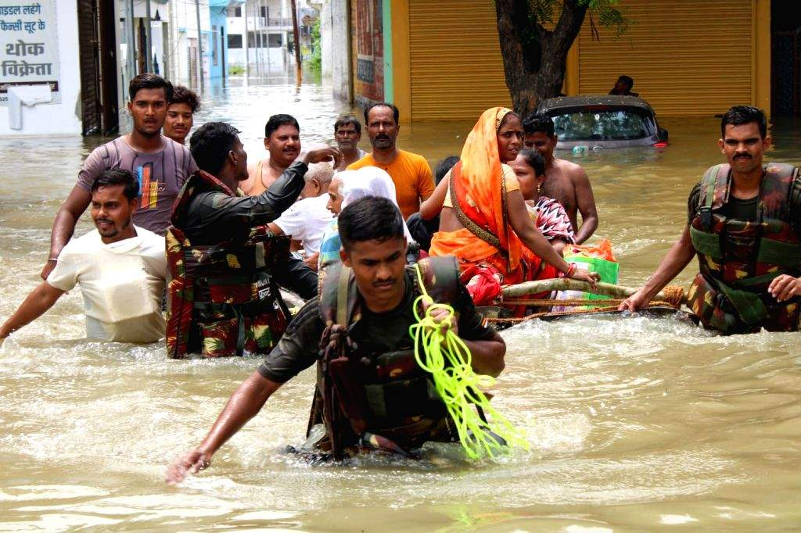

**Image 3.11: Indian Army personnel assisting in flood relief operations**

**3.4.3 Volunteer Organizations and NGOs**

**Red Cross Society:**

The Red Cross Society is actively involved in providing humanitarian aid during floods. They offer medical assistance, emergency shelters, and distribute food and water to affected communities.

**Local NGOs and Community Groups:**

Local non-governmental organizations (NGOs) and community groups play a critical role in flood response. They mobilize volunteers, provide immediate relief, and support long-term rehabilitation efforts.

**International Aid Organizations:**

Organizations such as the United Nations, World Health Organization, and various international NGOs provide aid and support during major flood events. They contribute resources, expertise, and financial assistance to bolster relief efforts

.

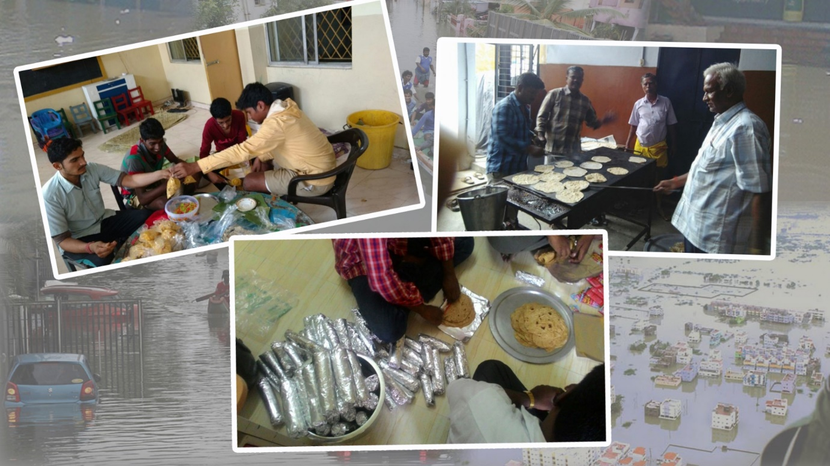

**Image 3.12: Volunteers distributing relief supplies to flood victims**

**Conclusion**

Addressing the challenges of flood management in Maharashtra requires a comprehensive approach that includes infrastructural improvements, administrative efficiency, financial investments, and community engagement. By implementing these remedies and fostering collaboration among various stakeholders, the state can significantly reduce the impact of floods and enhance resilience against future events.